12 Days Of Christmas

On the first day of Christmas father filed fifteen funnel cakes from France.
On the second day of Christmas Sophie sold seven sod filled sapphires to someone in Sweden.
On the third day of Christmas thirty thestrals thwarted the evil plans.
On the fourth day of Christmas forty fish fled from Fort Knox.
On the fifth day of Christmas fifty feeble fire trucks fainted.
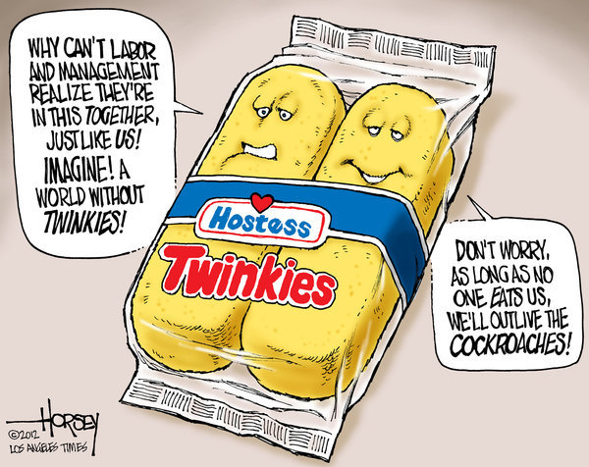
On the sixth day of Christmas seventy squakdepuses squawked so loud someone screamed.
On the seventh day of Christmas seven hundred Santas started smoking.
On the eighth eighteen elephants elegantly glided on evil eggplants.
On the ninth day of Christmas no one could stop the nuns dancing.
On the tenth day of Christmas turtles told twenty tabby cats that turtles could fly.
On the eleventh day of Christmas Ezekiel’s easels were excited.
On the twelfth day of Christmas twelve sets of twins twanged tongs with twinkies at twilight.

